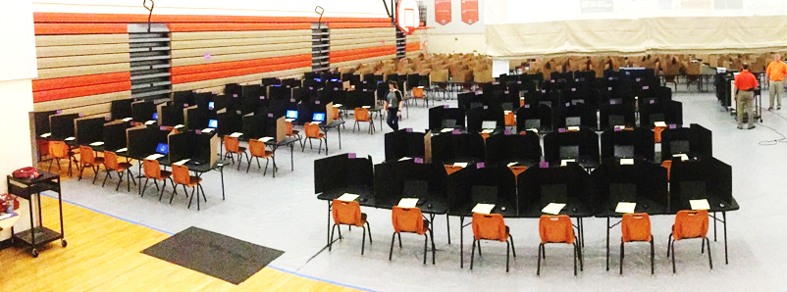
Gym Seating Chart Q1
Test: __________________Date: _______________Time: AM/PM
Session ID: ___________________Proctor 1__________________
Proctor 2______________Proctor 3 ___________________

Table |  | Table |  |  | Table |  | Table
72 | 71 | 70 | 69 |  | 68 | 67 | 66 | 65
Table |  | Table |  |  | Table |  | Table
64 | 63 | 62 | 61 |  | 60 | 59 | 58 | 57
Table |  | Table |  |  | Table |  | Table
56 | 55 | 54 | 53 |  | 52 | 51 | 50 | 49
Table |  | Table |  |  | Table |  | Table
48 | 47 | 46 | 45 |  | 44 | 43 | 42 | 41
Table |  | Table |  |  | Table |  | Table
40 | 39 | 38 | 37 |  | 36 | 35 | 34 | 33
Table |  | Table |  |  | Table |  | Table
32 | 31 | 30 | 29 |  | 28 | 27 | 26 | 25
Table |  | Table |  |  | Table |  | Table
24 | 23 | 22 | 21 |  | 20 | 19 | 18 | 17
Table |  | Table |  |  | Table |  | Table
16 | 15 | 14 | 13 |  | 12 | 11 | 10 | 9
Table |  | Table |  |  | Table |  | Table
8 | 7 | 6 | 5 |  | 4 | 3 | 2 | 1

