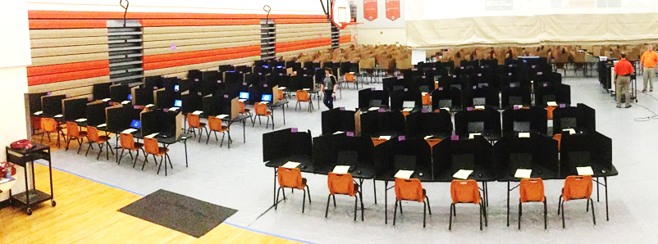
Gym Seating Chart Quadrant 1
Test: _________________________________Date: _________________Time: AM/PM
Session ID: ____________________________Proctor 1: __________________________
Proctor 2: _____________________________Proctor 3: __________________________
Each quadrant has 36 tables set up in 6 rows of 6 tables with a walking path down the middle. Each table has 2 chairs and 2 dividers. They are set up facing the center of the gym.
Table |  | Table |  | Table |  | Walking Path | Table |  | Table |  | Table
1 | 2 | 3 | 4 | 5 | 6 |  | 37 | 38 | 39 | 40 | 41 | 42
Table |  | Table |  | Table |  |  | Table |  | Table |  | Table
7 | 8 | 9 | 10 | 11 | 12 |  | 43 | 44 | 45 | 46 | 47 | 48
Table |  | Table |  | Table |  |  | Table |  | Table |  | Table
13 | 14 | 15 | 16 | 17 | 18 |  | 49 | 50 | 51 | 52 | 53 | 54
Table |  | Table |  | Table |  |  | Table |  | Table |  | Table
19 | 20 | 21 | 22 | 23 | 24 |  | 55 | 56 | 57 | 58 | 59 | 60
Table |  | Table |  | Table |  |  | Table |  | Table |  | Table
25 | 26 | 27 | 28 | 29 | 30 |  | 61 | 62 | 63 | 64 | 65 | 66
Table |  | Table |  | Table |  |  | Table |  | Table |  | Table
31 | 32 | 33 | 34 | 35 | 36 |  | 67 | 68 | 69 | 70 | 71 | 72

