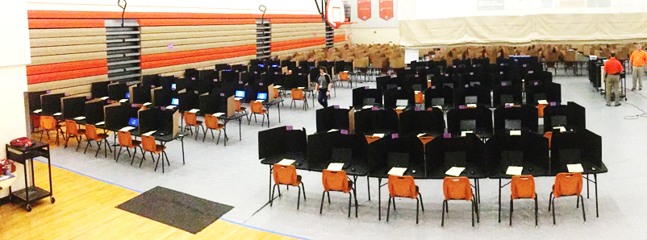
Gym Seating Chart Quadrant 3
Test: _________________________________Date: _________________Time: AM/PM
Session ID: ____________________________Proctor 1: __________________________
Proctor 2: _____________________________Proctor 3: __________________________
Each quadrant has 36 tables set up in 6 rows of 6 tables with a walking path down the middle. Each table has 2 chairs and 2 dividers. They are set up facing the center of the gym.
Table |  | Table |  | Table |  | Walking Path | Table |  | Table |  | Table
145 | 146 | 147 | 148 | 149 | 150 |  | 181 | 182 | 183 | 184 | 185 | 186
Table |  | Table |  | Table |  |  | Table |  | Table |  | Table
151 | 152 | 153 | 154 | 155 | 156 |  | 187 | 188 | 189 | 190 | 191 | 192
Table |  | Table |  | Table |  |  | Table |  | Table |  | Table
157 | 158 | 159 | 160 | 161 | 162 |  | 193 | 194 | 195 | 196 | 197 | 198
Table |  | Table |  | Table |  |  | Table |  | Table |  | Table
163 | 164 | 165 | 166 | 167 | 168 |  | 199 | 200 | 201 | 202 | 203 | 204
Table |  | Table |  | Table |  |  | Table |  | Table |  | Table
169 | 170 | 171 | 172 | 173 | 174 |  | 205 | 206 | 207 | 208 | 209 | 210
Table |  | Table |  | Table |  |  | Table |  | Table |  | Table
175 | 176 | 177 | 178 | 179 | 180 |  | 211 | 212 | 213 | 214 | 215 | 216

